ONLINE GAMING

A Project Report Submitted
for

Information Technology
By

Lokesh singh
(Roll no 22)

Under the guidance of
Mr. Praveen Kumar Joshi



EVER GREEN SENIOR SECONDARY SCHOOL
(GOVERNED BY EDUCATIONAL WELFARE SOCIETY)
TULARAMPUR - 223139, DISTRICT-NAINITAL
UTTARAKHAND, INDIA

OCTOBER, 2021

CERTIFICATE

This is to certify that the project entitled “ONLINE GAMING” being submitted to Evergeen Senior Secondary School, Haldwani for the project work of INFORMATION TECHNOLOGY is a record of the work carried by MR. PRAVEEN KUMAR JOSHI under my guidance and supervision.

Date: 6/10/2021 Supervisor
MR. PRAVEENJOSHI
TGT Computer
Ever Green Sr. Sec. School, Haldwani
Forwarded By:
MR. M.S. PARWAL
Principal
Ever Green Sr. Sec. School, Haldwani

ABSTRACT
Although online gaming is a form of entertainment, with parents’ support and guidance it can help children develop their creativity, nurture relationships with friends and improve strategic thinking.
It can also help them build perseverance to attain goals, build resilience and improve their communications skills so they know how to respect other people’s points of view.
Here is a list of ways that gaming has been proven to benefit children:

Learning and development benefits
A great source to develop early learning skills for younger children
Studies have shown that certain games can help younger children improve early reading skills with the support of parents and teachers. Games like ‘Times Table Rock Stars‘ that is used in primary schools and pre-school apps like ‘Endless Alphabet‘ can be great tools to help children learn in a more engaging way. Also, with the growth of connected toys, children can experience physical play while playing on devices. Educational toys like Osmo combines tactile play pieces with a device’s camera to bring to the in-play action to life.
Enhances memory, brain’s speed, and concentration
Games that are immersive and require strategy and problem-solving skills to win, require players to remember and take in a lot of information. Regularly playing these types of games can help improve children’s short and long-term memory and help the brain process information quicker.

Also, games capture players’ imagination helping them to stay focused on certain tasks and builds their perseverance to achieve a goal.
Improved multi-tasking skills
Games that require players to find items while fighting off other opponents call for attention to detail and quick reactions. Studies have shown that playing these types of games can help children develop their multi-tasking skills.
Build skills for future careers
The more complex multiplayer games help teach players how to be strategic, analytical to assess risk and reward and call for them to react quickly to changes in the game. All these skills that they use can be transferable to real-world jobs that rely on problem-solving, analytical skills and strategic thinking.
Offer a new way to understand culture and perspectives
As games allow children to immerse themselves in virtual worlds and at times connect to people from around the world, it can be a great way for them to learn about different perspectives and cultures.Promotes teamwork and builds confidence
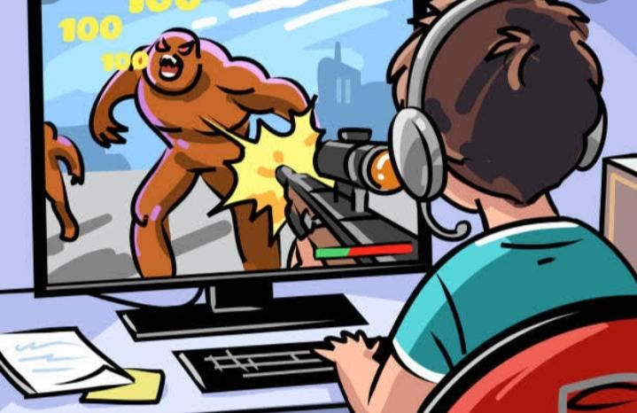
Multiplayer games allow children to take on a number of roles that allow them to learn how to manage a team if they are the leader or negotiate ways to win as part of a group. The shared experience can be a great way to collaborate and learn from each other to build children confidence.
Provides a fun way to stay active
The success of games like Pokemon GO and Zumba are an example of how games can help motivate children to stay active while gaming. Also, the rise of Mobile gaming apps means that children don’t have to be glued to a TV to play games, they can now, game on the GO. See our list of active apps that can help your child stay active while gaming.
Provide a way to develop compassion
There are a number of games and apps that have been developed to help children manage their emotions and encourage kind behaviour, compassion, and empathy. See our list of wellbeing apps to learn more.
Provide a safe context to talk about fears
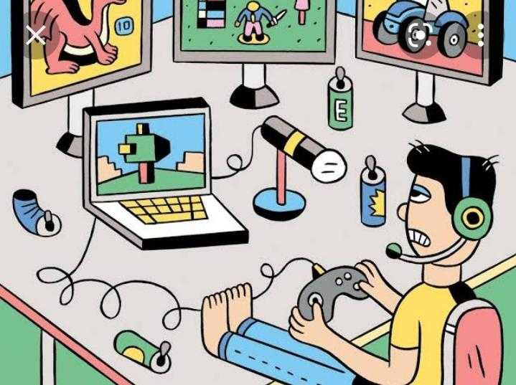
Sometimes it can be easier to talk about worries in a virtual context and games may provide a safe place for children to express themselves.
Are a new way to experience stories
Immersive games can help children experience stories in a more engaged way and shape the way the story is told to spark creative skills.
Create time and space for deeper thinking about topics
Schools are now using game-based learning more and more to help students understand and think about complex topics to help build math skills (i.e. STEM) or get to grips with concepts in science. Gamifying learning and allowing children to see things in a different way can encourage them to grasps topics faster and in a deeper way.
Physical and social benefits
Group play provides social benefits
Whether children are playing multiplayer games with friends or using apps like ‘Heads up’ with the family in the living room, these types of games can help nurture relationships through shared moments and improve their social skills. For some who children who may have disabilities, it can be a way for them to social and make friends if they are restricted.Gaming is a fun and sociable way to spend time, encouraging teamwork and developing skills. All good stuff, but there are a few things you need to be aware of:
Some games let children play and chat with anyone in the world. This means they might come across offensive language and bullying
Not everyone online is who they say they are. Children should avoid giving out personal details that could identify them or their location
Some games encourage players to buy extra elements during the game – children have been known to run up large bills without realising
In extreme cases bullying, also known as ‘griefing’, can be used as a tactic to win games. Children may find themselves either bullying or being bullied
Get involved by finding out what type of games your child enjoys and making sure they’re appropriate for their age
It can be hard to stop some games in the middle of a battle as there are penalties for quitting and children may feel they are letting teammates down.
Advantages of Online Gaming
1. Socialize
When playing online games. there is always a tendency to get socialize. Online gaming allows communication to take place between players of different regions. They can interact with each other while having fun. This will not only help them to get socialized, at the same time they will be a better team player.

2. Concentration
Frequently playing online games will make children's brain to function quicker and overall improve their memory power. Some online games require extensive planning and problem solving skills to complete levels. Therefore, children need to be mentally more active and concentrated.
3. Analytical Skills
While also online gaming helps to improve analytical skills. Using these skills, gamers should be able to respond quickly to the changes in the game. Even these analytical skills will be useful in real life where there is a need of immediate problem solving.
4. Relaxation
Online games are also known to promote relaxation. Obviously, games are one of the popular choices for entertainment. People with anxiety and depression can play online games to relieve stress. Not only children, even adults play online games for relaxation.
5. Revenue
Online gaming also makes it possible to earn money as long as it is a right platform. Based on the level of hardwork, they can significantly earn potential rewards. But only under the condition of 18 or above age. With increasing revenue, children might show positive attitude towards gaming.

ACKNOWLEDGEMENTS
I would like to express my most sincere heartfelt gratitude and respect to my supervisor MR. PRAVEEN JOSHI, for suggesting the topic for my project work and for his excellent guidance, valuable suggestions and endless support throughout for preparing the report. I am greatly indebted to him for his constructive suggestions and criticism from time to time during the course of progress of my work.
I would like to express my gratitude and sincere thanks to Mr. M.S. Parwal, Principal of School, and entire faculty who has imparted considerable knowledge to me.
Finally, I express my deepest gratitude to my parents for their continuous encouragement, understanding and support.

(Lokesh singh)

TABLE OF CONTENTS

Chapter | Topic | Page No.
 | CERTIFICATE | 1
 | ACKNOWLEDGEMENT | 2
 | LIST OF FIGURES | 4
 | ABSTRACT | 13
1. | INTRODUCTION | 1-2
1.1 | SUB HEADING | 1-2
1.2
1.2.1
1.2.2
1.2.3
2.
3.
4.
4.1
4.2
4.3
4.4
5.
6. | SUMMARY AND FUTURE WORK | 16
 | REFERENCES | 17-18

LIST OF FIGURES

S.No. | Name | Page No.
1. | Online gaming | 1
2. | Online gaming | 1
3. | Boy gaming | 1
4. | Lazyness from gaming | 1
5. | Online gaming | 1
6.
7.

